GitHub URl- https://github.com/Poorvitha17/Tutedude_Assignments

1. Grade Checker
Take a score as input and print the grade based on the following:
- 90+ : “A”
- 80–89 : “B”
- 70–79 : “C”
- 60–69 : “D”
- Below 60 : “F”
- Use a basic if / else statement to determine the grade.
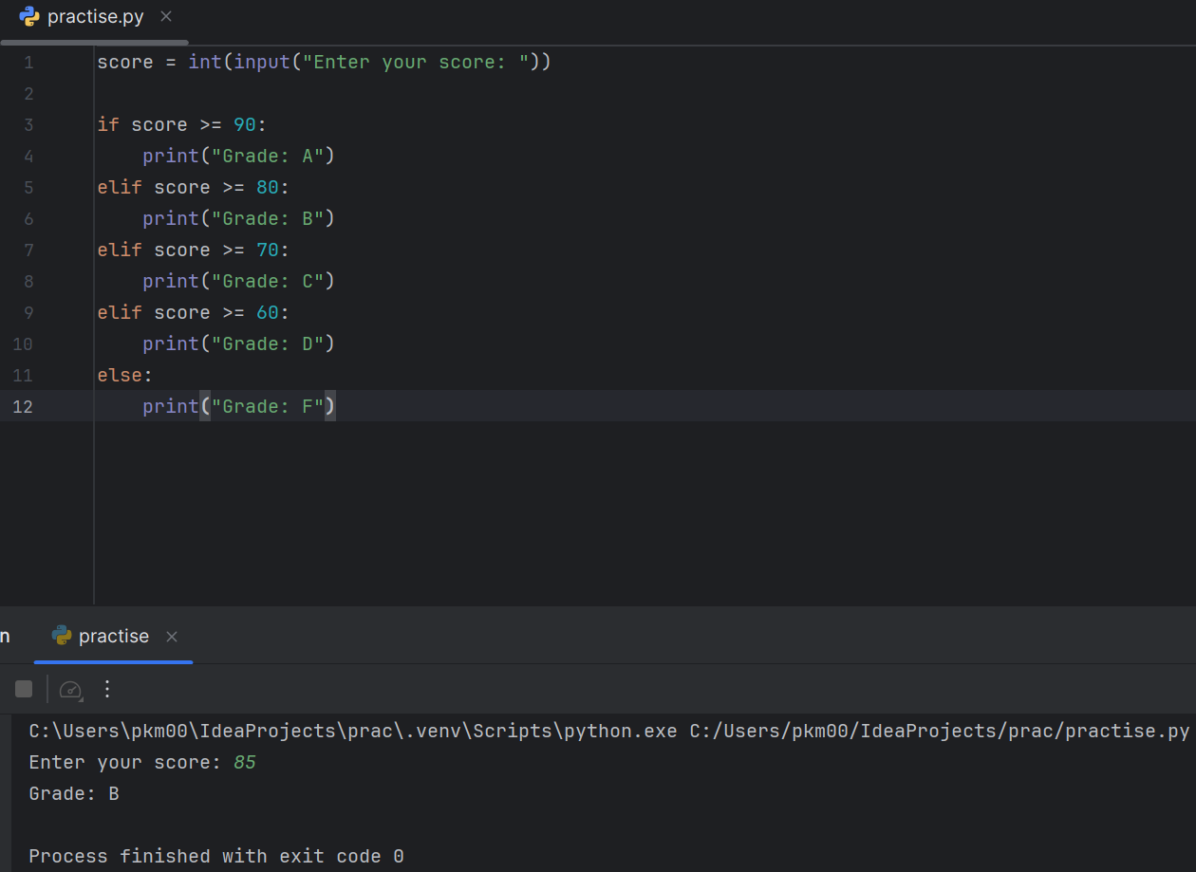
Why don't we write 80 <= score <= 89?
elif score >= 80:
input() → int() → if / elif / else → comparison operators.

2. Student Grades
Create a dictionary where the keys are student names and the values are their grades. Allow the user to:
- Add a new student and grade.
- Update an existing student's grade.
- Print all student grades.
- Use a dictionary and basic operations with if / else.
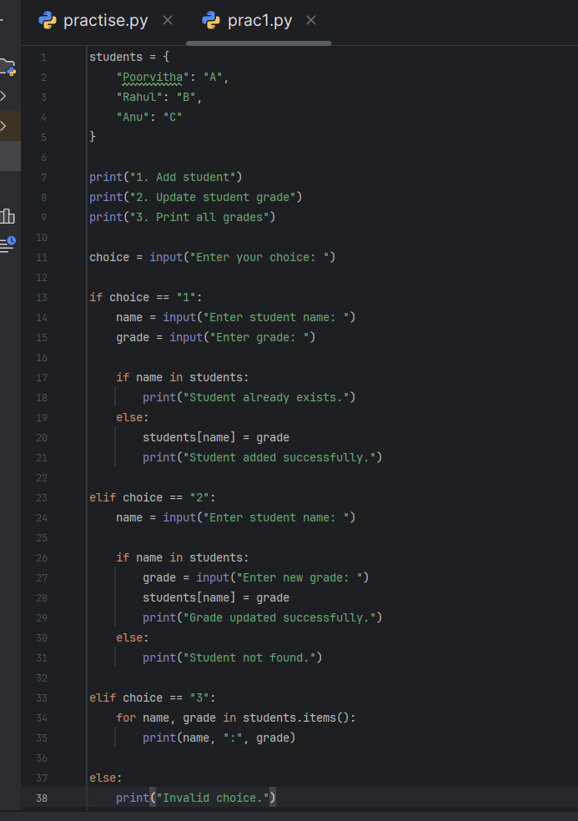
- 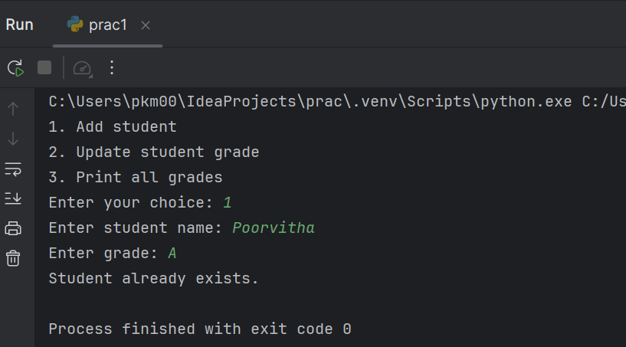
Here:
- "Poorvitha" → key
- "A" → value
So can access a grade using:
print(students["Poorvitha"])

updating uses the same syntax:

students["Poorvitha"] = "B"

3. Write to a File
- Write a program to create a text file and write some content to it, using file functions like open() and write().
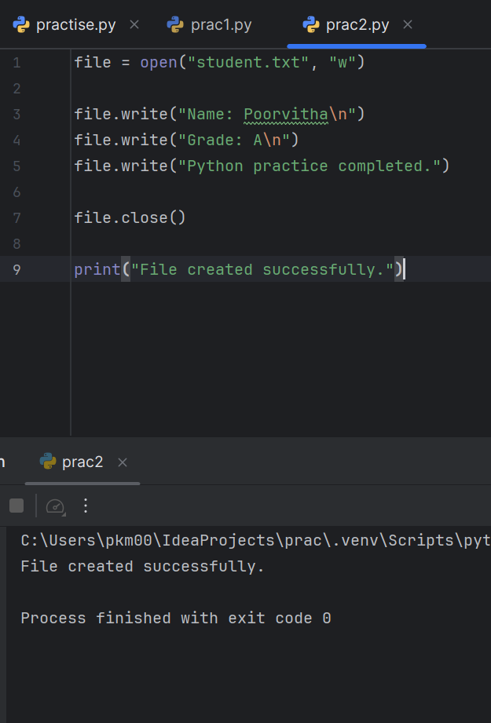
Open/create the file
file = open("student.txt", "w")
"student.txt" → file name
"w" → write mode
If the file doesn't exist, Python creates it.
If it already exists, "w" replaces its existing content.

file.write("Name: Poorvitha\n")
\n means new line.

"w" → write, creating/overwriting the file
"r" → read the file
"a" → append new content without deleting existing content

4. Read from a File
- Open the file in read mode and use file.read() to read and display its content.
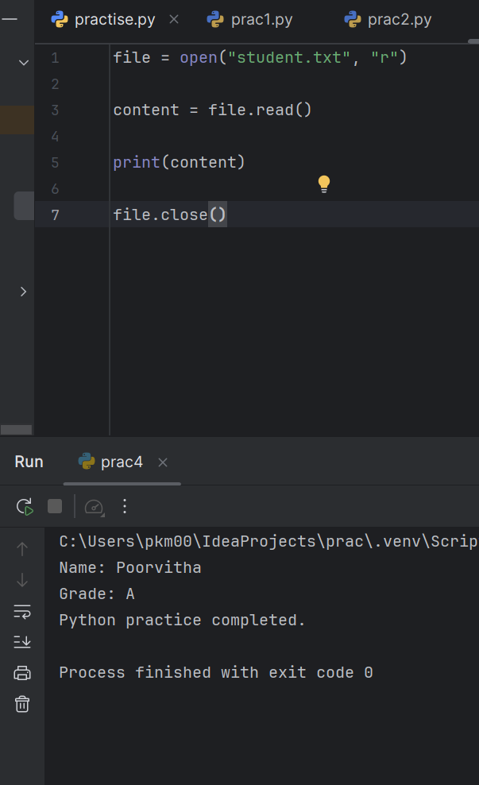
Open the file in read mode
file = open("student.txt", "r")
"student.txt" → file you want to open
"r" → read mode

Read the contents
content = file.read()

Display it
print(content)

